Lab11：Memory Mountain

Requirements
Platform: This lab assumes that you are using Visual C++ under a 32-bit version of Windows, using Intel Pentium or Pentium-equivalent machines. The exact compiler and platform are mostly unimportant, as the lab is reasonably portable.

Get to know your Cache
This platform of Intel Pentium machines has a memory hierarchy, which includes multi level of Cache, such as L1 cache, L2 cache, and sometimes L3 Cache maybe also exist.
You can use the some tools, such as everest.exe, to find out the basic information of Cache of the computer system, which you are uings.
For example, to using everest.exe, just double-click to run it. After it makes some information collection, it will show all the information about you computer system in its frame.
The following is an example of its main frame. You can see the information about the Cache.
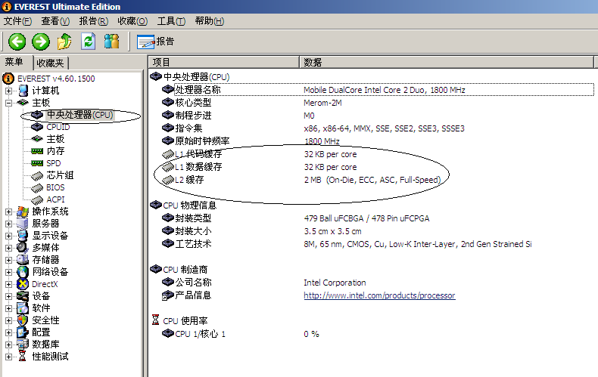

Now, run everest.exe to find out the information of your computer system’s Cache, and fill the blank.
Type | Size in byte
L1 cache | -
L2 cache | 256kb percore
L3 cache | 4mb

The project of memory_mountain
Please download the project of memory_mountain.rar first.
This project if the Windows-version of CMU CSAPP of mountain.c, which you can find in
- the textbook chapter 6.6(Notes: this is the first version),
- or from http://csapp.cs.cmu.edu/public/1e/public/code.html/mountain.c(Notes: this is the first version)
- or from http://csapp.cs.cmu.edu/public/code.html/mountain.c(Notes: this is the second version)

Your Task
1．Read the source code in mountain.cpp, and answer the following questions: (Notes: you don’t have to pay too much attention on the function fcyc2() )
1) What is the variable of size and stride used for?
size代表的是我们当前要访问的数组data的一个范围大小，stride表示的是每次访问之间相隔多少个下标
1) What is the meaning of the return value of the function run()?
这个run里面是通过每秒钟能够遍历多少次我们指定的工作集来返回一个吞吐量的，所以我们首先可以得到一个一秒钟遍历多少次的一个变量cycle，然后我们总共遍历读取的byte数为工作集大小size处以stride步长，所以我们最后得到的这个返回值是一个从一秒钟以stride遍历工作集的次数转换成的吞吐量。

2．If necessary, make some change to the value of MINBYTES, MAXBYTES, and MAXSTRIDE.
3．Build the project and run it, the you can get an output file named as out.txt.
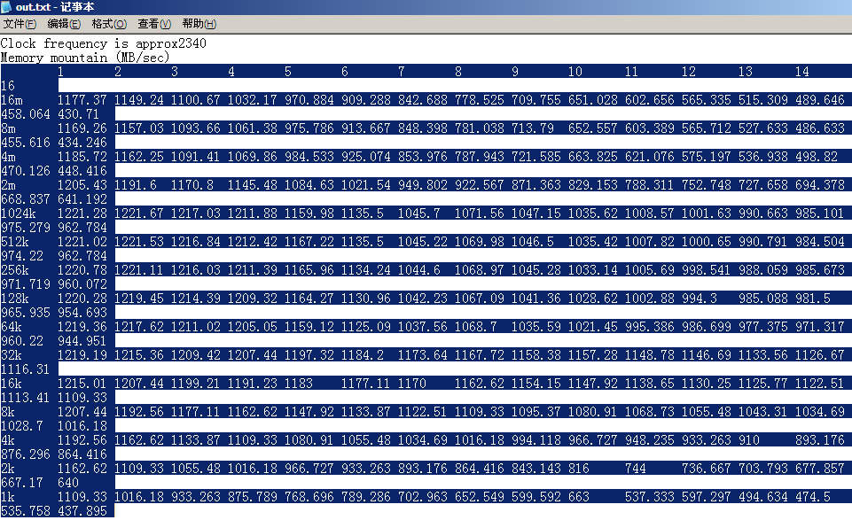
4．Copy the data in out.txt into an Excel file. Just as shown in the following figure.
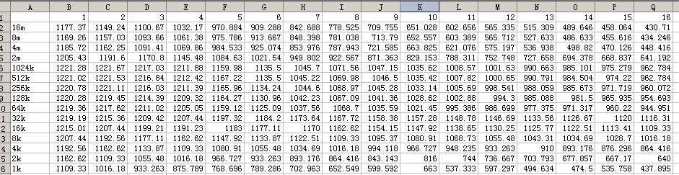
5．Click any cell in this Excel file, then add a chart.
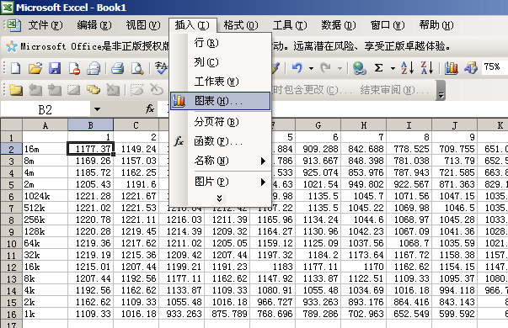

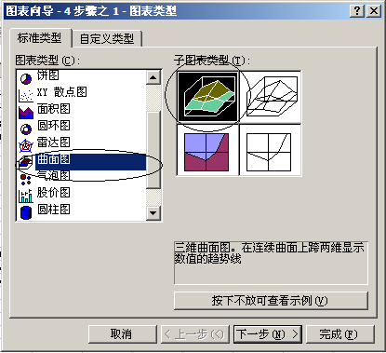

Then click Finish.

5．Then you can get a figure alike this:
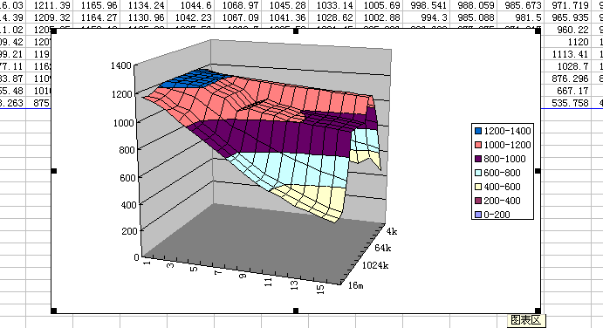

6. The following two figures are from CSAPP e1 and CSAPP e2
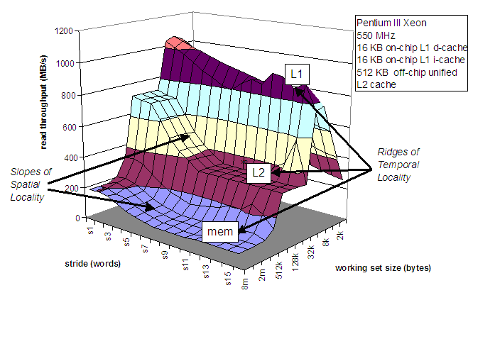
Figure of CSAPP e1

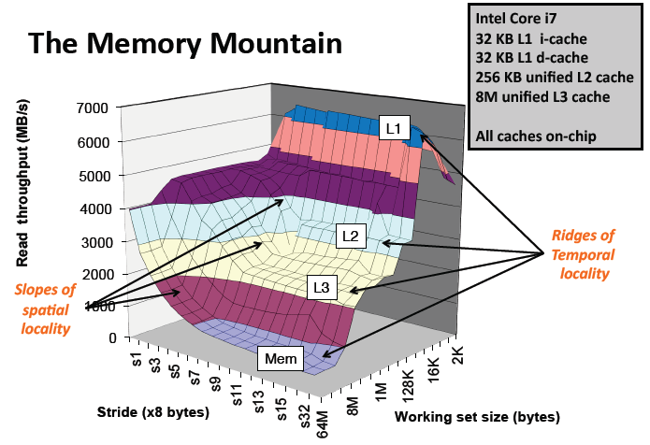
Figure of CSAPP e2

7．Just Paste your figure here:
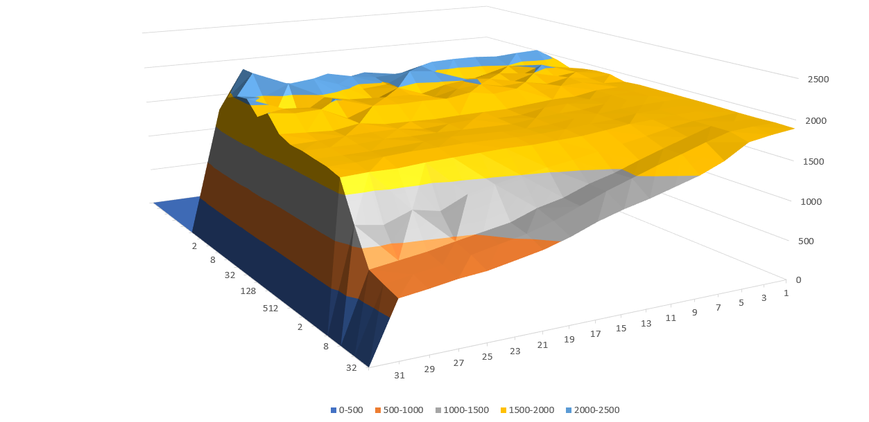
8．How many ridges(山脊) do you get? And what are they corresponding to?
在2k到8k之间有一个明显的ridge，在2M到8M之间又有一个很大的ridge
9．Just compare the mountain with the information that you just got by running as everest.exe. And explain How the spatial locality and temporal locality are shown in this figure.
我们可以看到，在相同步长的时候吞吐量首先是在2k到8k之间出现了一些下降，这说明访问的一级缓存命中率有了下降，但是在工作集超过512K过后并没有明显的下降，这只能说可能处理器23级缓存速度都挺快？还是可能有一些优化？然后2M到8M中间这个下降的话因为超过4m过后就不再是cpu内部的缓存了，而是需要到内存去找数据了，所以这里的ridge是合理的。所以就空间局部性来说，，对于同一个大小的工作集，当然步长越小那么空间局部性越好因为他的下一次访问很有可能也在cache里面，如果步长大了就会导致下一次要访问的内容可能在内存或者硬盘里，比如我们看工作集为32m的时候，就非常明显，图表里面随着步长的增加吞吐量下滑
就时间局部性来说，如果工作集的size比较大，那么我们访问同一个元素中间要隔的时间就要比工作集小的时候长，这样的情况可能导致一次pass的过程中先访问的元素被换出cache，所以可以看到当步长相同时工作集越大的时候吞吐量越低

